Order Of Service

Singing: Psalm 139b—CW page 117

Reading: Psalm 8

Opening Hymn: TLH 13

Reading: I John 2:18-29

Request Hymn: CW Supplement 702

Reading: John 1:1-18

Sermon Hymn: TLH 17

Sermon Text: Song Of Solomon 3:10

Silver, Gold, & Purple

Prayer

The Apostles’ Creed, TLH page 12

Holy Communion

The Lord's Prayer

The Blessing

Closing Hymn: TLH 46

* * * * * * * * * * *

Bible Study: Lambs: Genesis 12:1-3; Walking By Faith
Sheep: Proverbs 10:13-14; Your Choice
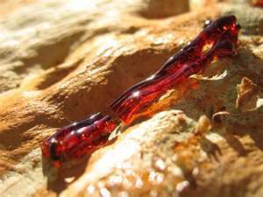

The Scarlet Worm

Water
Of
Life

19 June 2016

W A T E R O F L I F E

Independent Christian Church—Conservative Lutheran Doctrine

Worship Service: 9:30 a.m. Bible Study: 10:45 a.m.

Larry Cooper, Pastor E-Mail address:
111 N. Ridge Road lcooper@wateroflife.cc
Coon Valley, WI 54623 Web Site:
Phone: (608) 452-2105 www.wateroflife.cc

* * * * * * * * * * * * * * * * * * * * * * * * * * *

Sermon Text: Song Of Solomon 3:10

Silver, Gold, & Purple

* * * * * * * * * * * * * * * * * * * * * * * * * * *

Song of Solomon 3:10 He made the pillars thereof of silver, the bottom thereof of gold, the covering of it of purple, the midst thereof being paved with love, for the daughters of Jerusalem.

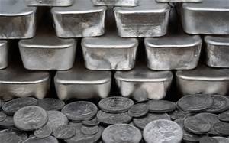

In the opening verses of Genesis 13 the Holy Spirit tells us: Genesis 13:1 And Abram went up out of Egypt, he, and his wife, and all that he had, and Lot with him, into the south. :2 And Abram was very rich in cattle, in silver, and in gold. Very early in history these two metals were counted as being very precious. Same is true even today.



It is no surprise to us, then, that we find both silver and gold used in the construction of Solomon’s Chariot. “He made the pillars thereof of silver, the bottom thereof of gold.” Both silver and gold have special spiritual connotations in Scripture. We’ll look at some of them this morning.

The Holy Spirit also mentions concerning Solomon’s Chariot that “the covering of it (was) of purple.” This information is precious beyond words. We’ll take a special look at the color “purple” this morning.

And finally, everything mentioned in this verse is “paved with love.” And this “love” is offered to “the daughters of Jerusalem.”

Here we can’t help but think of John 3:16! “For God so loved the world, that he gave his only begotten Son, that whosoever believeth in him should not perish, but have everlasting life.”

